## Punjab (the land of five rivers) is the biggest land area of Pakistan and is popularly known for its culture. It shares most of its cultural and carnival values with Indian culture. According to population, 56% of the total population of the country is situated in Punjab Province. It has a total of 36 districts and contributes approximately 50-60 % of the economy.

## 

## History

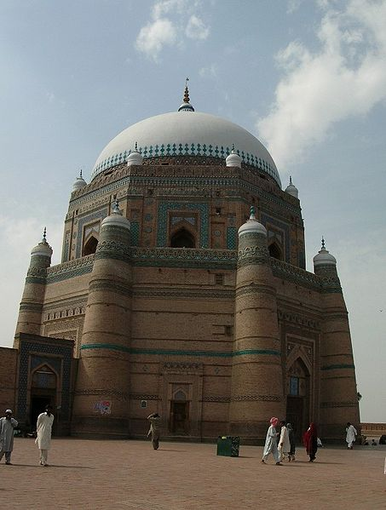 Punjab has been the cradle of civilization since times immemorial. The ruins of Harappa show an advanced urban culture that flourished over 8000 years ago. Taxila, another historic landmark also stands out as a proof of the achievements of the area in learning, arts and crafts. The ancient Hindu Katasraj temple and the Salt Range temples are regaining attention and much-needed repair. The structure of a mosque is simple and it expresses openness. Calligraphic inscriptions from the Quran decorate mosques and mausoleums in Punjab. The inscriptions on bricks and tiles of the mausoleum of Shah Rukn-e-Alam (1320 AD) at Multan are outstanding specimens of architectural calligraphy. The earliest existing building in South Asia with enameled tile-work is the tomb of Shah Yusuf Gardezi (1150 AD) at Multan. A specimen of the sixteenth century tile-work at Lahore is the tomb of Sheikh Musa Ahangar, with its brilliant blue dome. The tile-work of Emperor Shah Jahan is of a richer and more elaborate nature. The pictured wall of Lahore Fort is the last line in the tile-work in the entire world.

## Literature

Punjab is very rich with literature and Sufis adds more in its literature. Punjabi poetry is renowned for its extremely deep meaning, beautiful and hopeful use of words. The large number of Punjabi poetry is being translated throughout the world into many languages. Some famous poets of Punjabi are Sultan Bahu, Mia Mohammad Baksh, Baba Farid, Shah Hussain, Anwar Masood etc. Waris Shah, whose contribution to Punjabi literature is best-known for his seminal work in Heer Ranjha, known as Shakespeare of Punjabi language. Bulleh Shah was a Punjabi Sufi poet, a humanist and a philosopher. The verse from Bulleh Shah primarily employed is called the Kafi, a style of Punjabi. Some other popular folk tales of Punjab include Sassi-Punnu, Sohni Mahiwal etc. that are passing through generations.

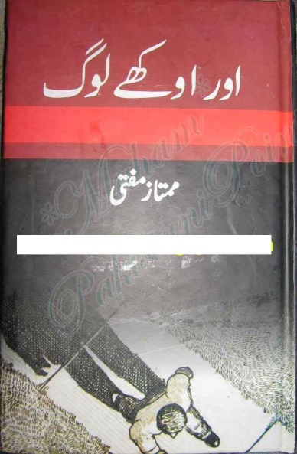

## Music & Dance

Bhangra is most commonly known Punjabi music genre and dance style. Punjabis passionately love folk songs/music, Qawali and Punjabi music is recognized throughout the world. The Tabla, Dhol, Dholki, Chimta, Flute and Sitar are all common instruments of this delightful culture. Punjabi dance is based around happiness, energy and enthusiasm.

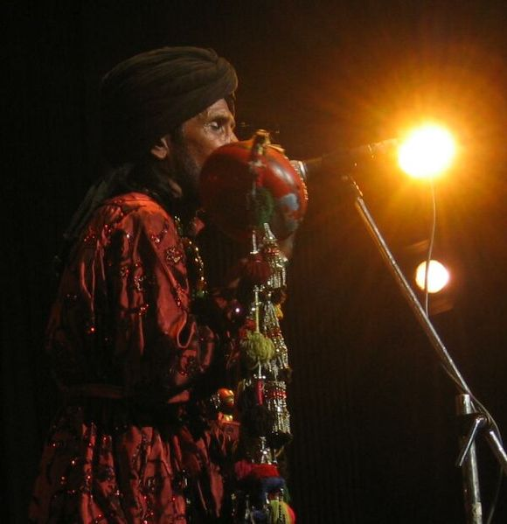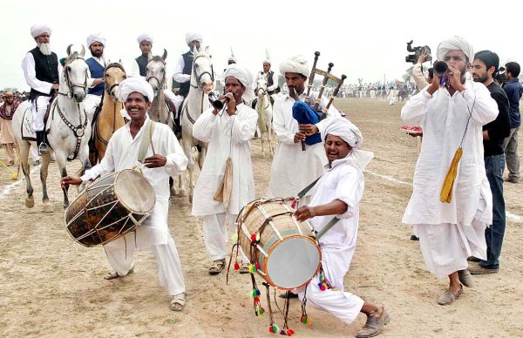

Different forms of dance in Punjab are: Loddi, Dhamal, Sammi, Kikli, Gatka, Bhangra, Giddha and Dandiya. Punjabi dances have been embraced by the American culture and others alike and now they are one of the most appreciated art forms.

## Sports

## Punjabi people have fanatical interest in sports. Punjabi’s are fond of kabaddi, and wrestling, which is also popular in other parts of Pakistan and it’s also played on national level. Other games being played in Punjab region include Gilli-Danda, Khoo-Khoo, Yassu-Panju, Pitho-Garam, Ludo, Chuppan-Chupai, Baraf-Panni, Kanchy and some major sports include cricket, boxing, horse-racing, hockey and football. National Horse and Cattle Show at Lahore is the biggest festival where sports, exhibitions, and livestock competitions are held.

## 

## FOOD

The extensive cuisine of Punjab can be vegetarian and non-vegetarian. One commonality between all Punjabi dishes is the liberal usage of ghee or clarified butter spices and Punjabis are fond of sweet-meats also. Most Punjabi food is eaten with either rice or roti. There are some dishes that are exclusive to Punjab such as Mah Di Dal, Paratha, Makai ki rotti, Saron Da Saag, and in cities Choley, Haleem, Baryani and other spicy dishes are popular. In beverages, tea is consumed in all seasons and as a custom most of Punjabis serve tea to their guests. Punjabis are also fond of Zarda, Gulab-Jamuns, Kheer, Jalaibi,Samosy, Pakorey etc. During summers people drink lassi, doodh-soda, aloo bokharey ka sharbat, lemonade etc. These cuisines have become world-wide delicacies with large scale representation.

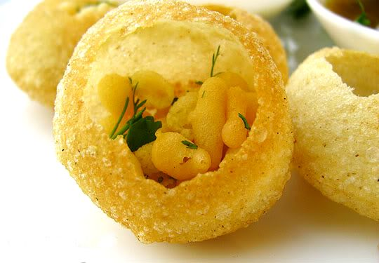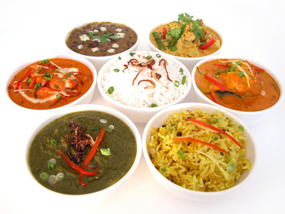

## CLOTHING

Costumes of Punjab are an indication of the bright and vibrant culture and lifestyle of the people.The costumes are a mix of colours, comfort and beauty and Punjab is well known for the use of phulkari(embroidery) in its costumes. In most of the villages of Punjab men wear Pagri(turban), dhoti/lacha, kurta, khusa.

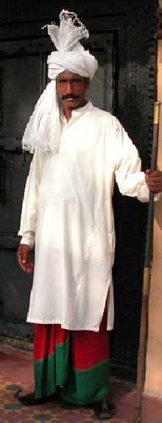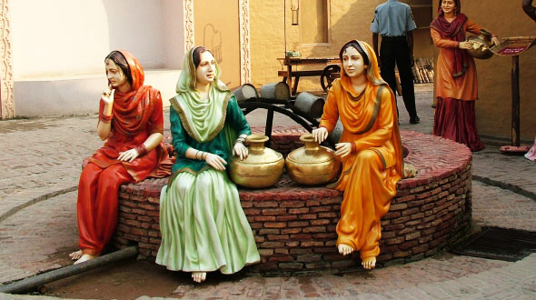

Women wear gharara, or choridar pajama or colorful shalwar kameez, paranda, choli/duppata, khusa, kola puri chappal or tillay wali jutti. Whereas in urban areas of Punjab men and women follow latest trends and fashion, generally they wear different styles of shalwar kameez.